**Lab Manual for Computer Communication and Networking**

**Lab No. 5**

**VLAN Trunking Protocol(VTP)**

**BAHRIA UNIVERSITY KARACHI CAMPUS**

**Department of Software Engineering**

**COMPUTER COMMUNICATION & NETWORKING**

**LAB EXPERIMENT # 5**

VTP (Vlan Trunking Protocol)

**OBJECTIVE: -**

* This lab assignment helps in understanding how VTP (Virtual Trunking Protocol) can be configured on a Cisco switches.

**EQUIPMENT: -**

1. Ethernet Cable
2. Two Switches
3. Console Cable
4. Two PC’s

**THEORY: -**

The basic objectives of VLAN Trunking Protocol (VTP) are to manage all configured VLANs across a switched internetwork and to maintain consistency throughout that network. VTP allows you to add, delete, and rename VLANs—information that is then propagated to all other switches in the VTP domain. Here’s a list of some of the cool features VTP offers:

* Consistent VLAN configuration across all switches in the network.
* Accurate tracking and monitoring of VLANs.
* Dynamic reporting of added VLANs to all switches in the VTP domain.
* Plug and Play VLAN adding.

**NETWORK TOPOLOGY: -**

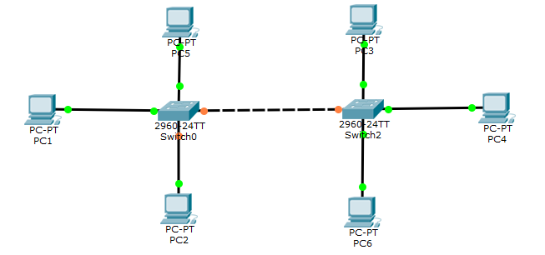

**PROCEDURE:**

Switch>en

Switch#config t

Enter configuration commands, one per line. End with CNTL/Z.

Switch(config)#int fa0/3

Switch(config-if)#switchport mode trunk

Switch(config-if)#switchport trunk allowed vlan 1-99

Switch(config-if)#end

**VTP CONFIGURATION:**

Switch# show vtp status

Switch(config#) vtp mode (server/client/transparent)

Switch(config#) vtp domain mydomain

Switch(config#) vtp password cisco

**QUESTIONS: -**

1. **Take 4 switches named as: A, B, C, D and connect them in alphabetical order.**

**Perform and show the following configurations in your lab task:**

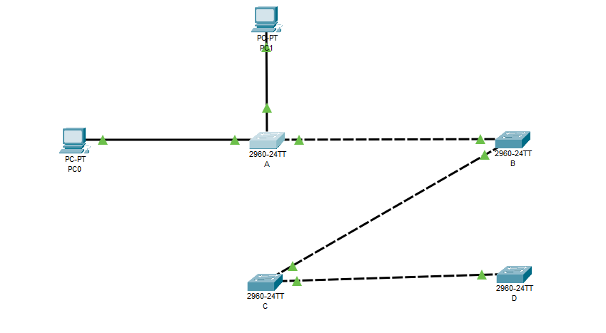

* 1. **Switch A with VLANs faculty and students having 1 logical port each.**

**Create VLANs**

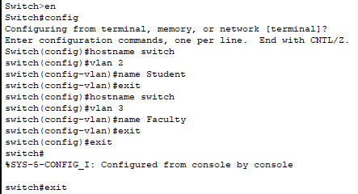

**Show VLANs**

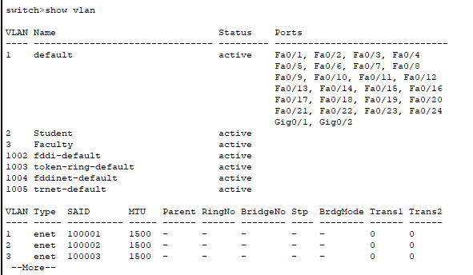

**Assign Ports**

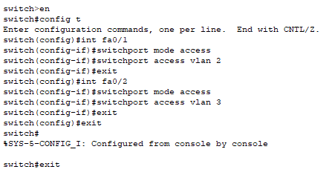

**Show VLANs**

* 1. **Now assign 1 logical port each to VLANs faculty and students in Switch B and D.**

**Switch B**

**Create VLANs**

**Show VLANs**

**Assign Ports**

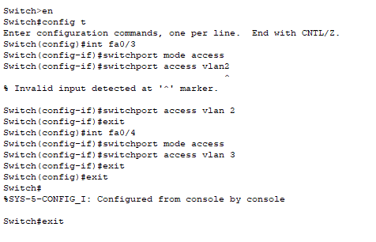

**Show VLANs**

**Switch D  
Create VLANs**

**Show VLANs**

**Assign Ports**

**Show VLANs**

* 1. **Now make switch A in server mode, whereas B and D in client mode and switch C in transparent mode.**

**Trunk Between the Switch A & B**

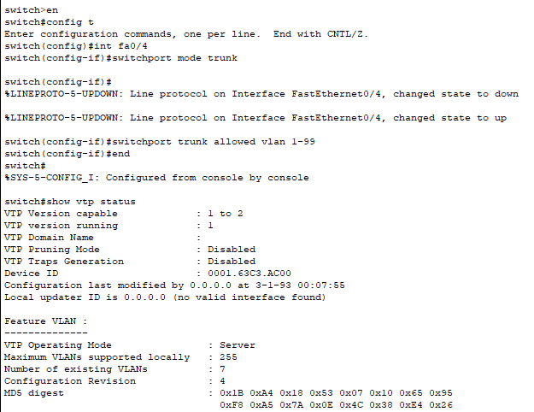

**Create Switch A Server**

**Trunk Between the Switch B & C**

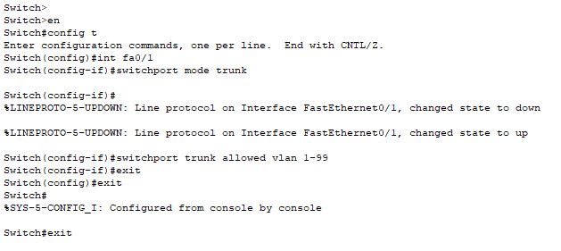

**Create SwitchB Client**

**Trunk Between the Switch C & D**

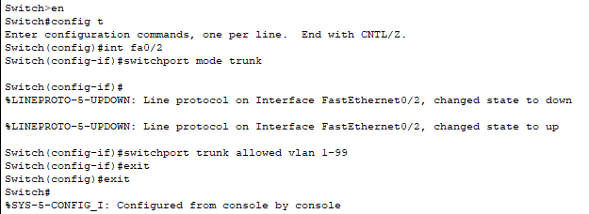

**Create SwitchC Transparent**

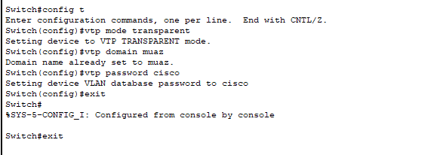

**Create SwitchD Client**

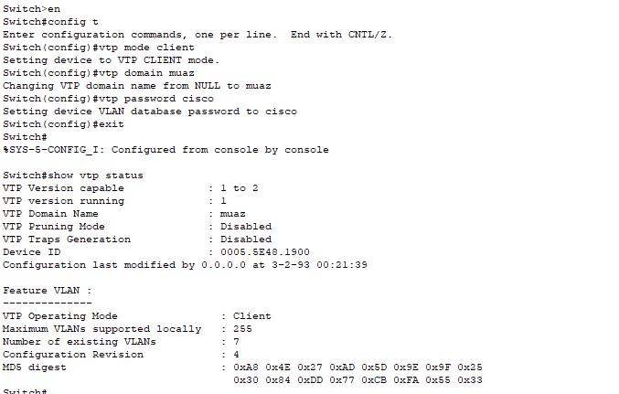

* 1. **Assign IP addresses to PCs connected to Switch A, B and D.**

|  |  |  |
| --- | --- | --- |
| **Switch** | **PC’s** | **IP** |
| **S1** | **Faculty** | 192.168.0.1 |
| **S1** | **Student** | 192.168.0.2 |
| **S2** | **Student** | 192.168.0.3 |
| **S2** | **Faculty** | 192.168.0.4 |
| **S3** | **Faculty** | 192.168.0.5 |
| **S3** | **Student** | 192.168.0.6 |

* 1. **Now ping within the same VLAN and outside the same VLAN and show your results.**

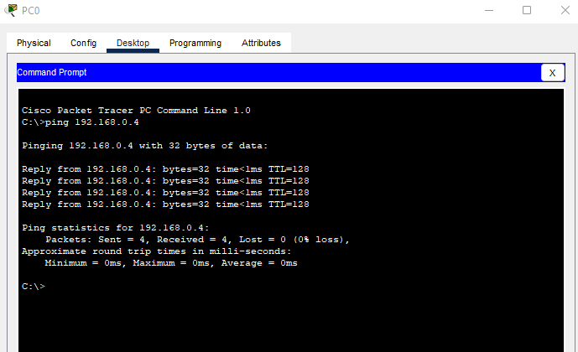

**Outside VLAN**

**TIME BOXING:**

|  |  |  |
| --- | --- | --- |
| **Activity Name** | **Activity Time** | **Total Time** |
| **Instruments Allocation + Setting up Lab** | 10 mints | 10 mints |
| **Walk through Theory & Tasks (Lecture)** | 60 mints | 60 mints |
| **Implementation & Practice time** | 90 mints | 80 mints |
| **Evaluation Time** | 20 mints | 20 mints |
|  | Total Duration | 180 mints |

**Teacher Signature**: ________________________

**Student Registration No**: ________________________